2.2 Demonstrate using Selenium tool in Jenkins Pipeline

1. Prerequisites
- Jenkins is installed and running.
- Java and Maven are installed on the Jenkins server/agent.
- Jenkins has access to your Git repository (e.g., GitHub).
- Your Java project has a valid pom.xml.

2. Install Required Plugins
Go to Manage Jenkins → Manage Plugins → Available, and install:
- Git plugin
- Maven Integration plugin
- JUnit plugin (for test results)

3. Configure Global Tools (if not already done)
Navigate to Manage Jenkins → Global Tool Configuration:
- Maven: Add a Maven installation (e.g., name it Maven 3.8.1).
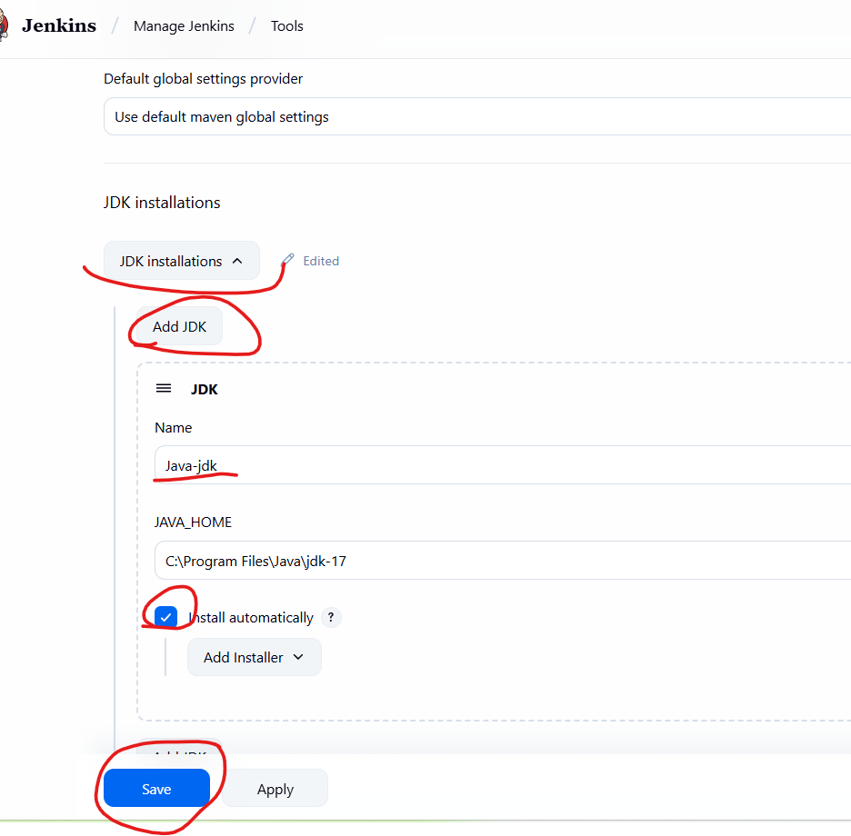
- JDK: Add a JDK (e.g., JDK 8) and make sure it points to a valid Java path.

4. Create a Freestyle Job
Go to Jenkins Dashboard → New Item → Freestyle Project
- Name: java-freestyle-job
- Click OK

5. Configure Source Code Management
- Under Source Code Management, choose Git
- Enter your repository URL (e.g., https://github.com/your-name/hello-world.git)
- Add credentials, To Add credentials
Login to Github,
Go to GitHub Home
Click your profile photo (top-right)
Click “Settings”
In the left sidebar, scroll all the way down
You should see “Developer settings” at the bottom
Click Personal access tokens → Tokens (classic)

2. Click “Generate new token”
- Choose: Generate new token (classic)

3. Fill in Token Details:
- Note: A name/label for your token (e.g., “Jenkins Access”)
- Expiration: Choose expiry (e.g., 30 days, 90 days, or “No expiration”)
- Scopes: Select the access rights you need (see below)
4. Click “Generate token”
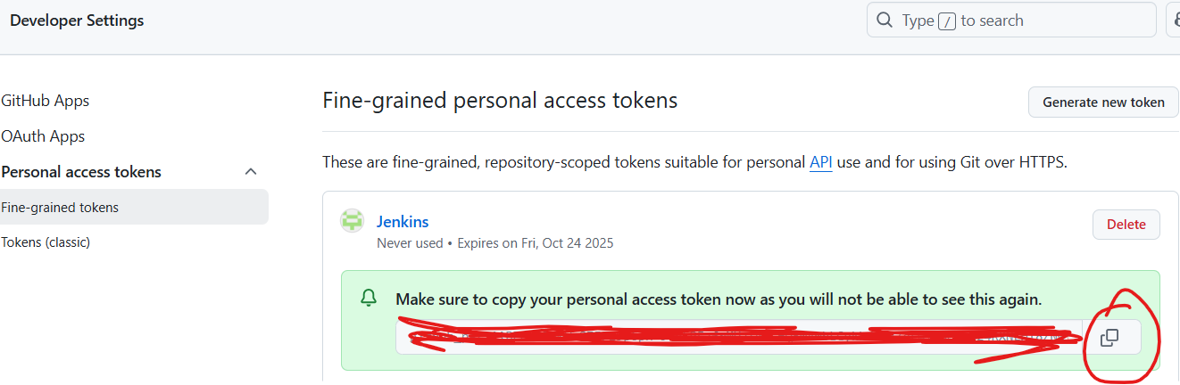

1. Open Jenkins Project Configuration
- Go to Jenkins dashboard.
- Click on your job/freestyle project.
- Click on “Configure”.

2. Scroll to “Source Code Management”
- Select Git.

3. Enter Repository URL
- Paste your GitHub repo URL in Repository URL field.

4. Click “Add” Next to Credentials
- On the right side of the “Credentials” dropdown, click the [Add] button.

5. In the Add Credentials Dialog:
Choose the type depending on your access method.

▶ For HTTPS (GitHub username + personal access token):
- Kind: Username with password
- Username: Your GitHub username
- Password: Your GitHub Personal Access Token (PAT) (not your actual password)
- ID (optional): Leave empty or name it for later reuse
- Description: e.g., “GitHub Access Token”
Click Add.

Configure Source Code Management
- Under Source Code Management, choose Git
- Enter your repository URL (e.g., https://github.com/your-name/hello-world.git)
- Select the Added credentials
- Choose the correct branch (e.g., main)
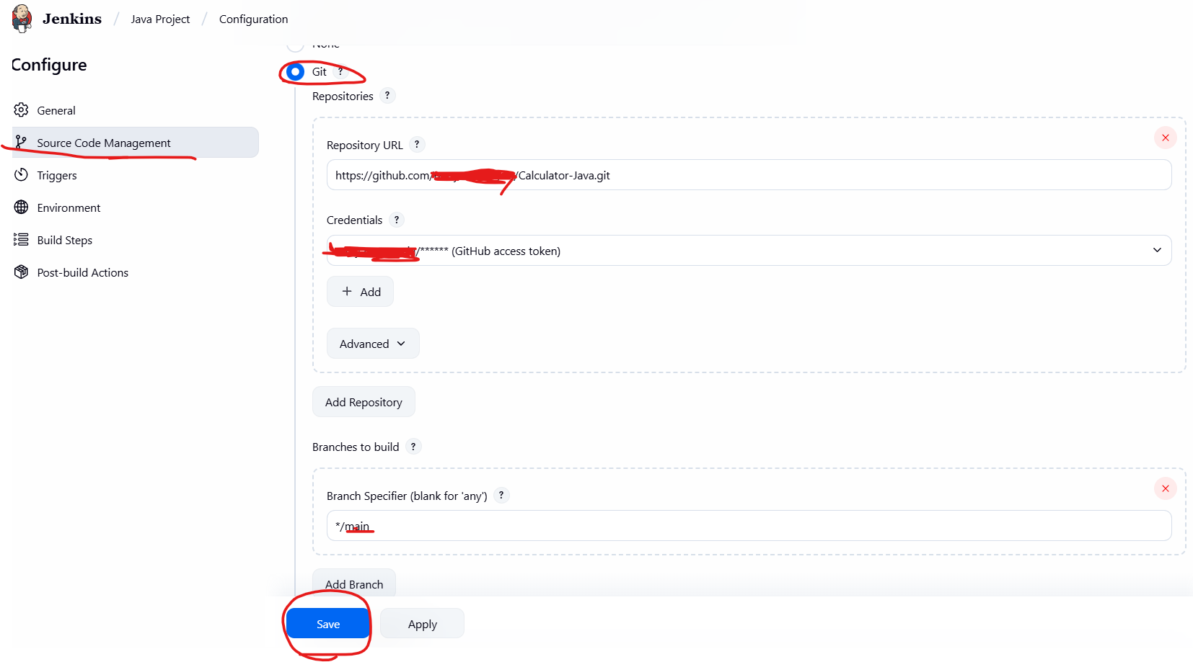

6. Build Triggers
(Optional but recommended)
Select Poll SCM if you want Jenkins to check Git regularly:
sql
CopyEdit
H/5 * * * * (poll every 5 minutes)
- Or use GitHub Webhook to trigger on every push.

7. Build Environment
- Check Delete workspace before build starts (to avoid stale builds)

8. Build Steps
Under Build, click Add build step → Invoke top-level Maven targets
Goals:
bash
CopyEdit
clean install

This will:
- Clean the target folder
- Compile the code
- Run tests
- Package the .jar or .war

9. Post-build Actions
Click Add post-build action → Publish JUnit test result report
Test report XMLs:
bash
CopyEdit
**/target/surefire-reports/*.xml

(Optional):
- Add Archive the artifacts:
  - **/target/*.war or **/target/*.jar
  - This will store your build outputs in Jenkins.

10. Save and Run
- Click Save
- On the project dashboard, click Build Now
✅ Jenkins will:
- Clone your Git repo
- Build your Java project using Maven
- Run unit tests
- Archive test results and artifacts

📊 Monitor Results
- Click on a specific build (e.g., #1)
- Check Console Output for logs
- View Test Results and Artifacts

